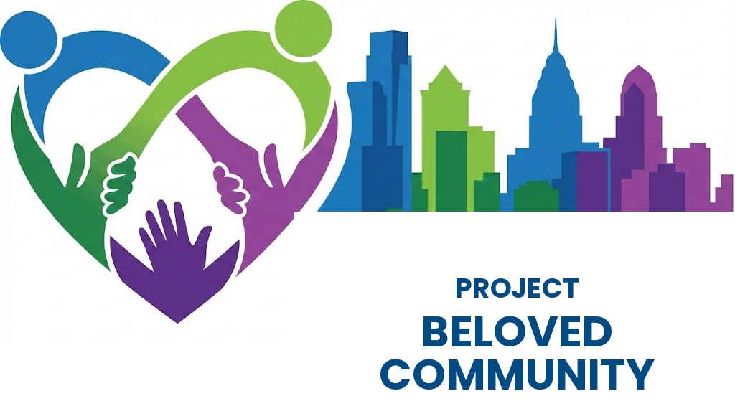
A Philadelphia Response to Project 2025 and the Trump Agenda
The Crisis
Philadelphia faces an affordability emergency. 300,000 residents live in poverty — the 2nd highest rate among major American cities. 40,000 families languish on housing waiting lists. Black Philadelphians face a poverty rate of 24.5%, nearly double the rate for white Philadelphians, reflecting centuries of deliberate exclusion from wealth-building opportunities.
Meanwhile, Wall Street banks hold billions in city deposits, extracting wealth while our neighborhoods crumble. Federal aid that our most vulnerable neighbors depend on is being cut. This is not inevitable. It is a policy choice. And we can choose differently.
The Vision
Project Beloved Community is a comprehensive, 10-year initiative to transform Philadelphia’s economy through democratic ownership. Not charity. Not dependency. Ownership — of housing, of businesses, of financial institutions, of our collective future. We will replace the resources taken by the Trump Administration, reverse its policies, and repair the long-term damage of structural racism.
Nine interconnected tools: A Philadelphia Public Bank to keep our money working locally. Pension fund investments redirected to community needs. Worker, consumer, and housing cooperatives. Community Land Trusts for permanent affordability. Resident-controlled social housing at scale, federated for shared services and political durability. Solar cooperatives and schools as community anchors. Living wages for all city-connected workers. And community safety through restoration, not incarceration.
Concrete targets:
IMMEDIATELY: Food assistance restored for up to 45,000 Philadelphia residents losing federal SNAP benefits.
OVER TEN YEARS:
• 65,000 permanently affordable homes
• 40,000–55,000 Black Philadelphians in living-wage jobs
• Approximately $1 billion in new Black household wealth
• A 50% reduction in the Black poverty rate
• A 90% reduction in gun violence in the neighborhoods most affected
Why It’s Achievable
This is not a wish list. Every element can be funded through existing City Council authority — no state legislation required.
Total 10-year capital need: $10.66 billion for the Nine Pillars program. Funded by tax measures under existing City authority, the Philadelphia Public Bank once chartered, pension fund investments redirected to community needs, the 2033 pension dividend, and City reserves — supplemented by voluntary commitments from anchor institutions, sports franchises, foundations, and a Bank Reinvestment Compact under which Philadelphia’s commercial banks would double and redirect their community grants and development lending.
A strategic offer to the business community. PBC restores the Business Income and Receipts Tax to the rate Philadelphia held from 1989 to 2017 — but if Philadelphia’s banks meet the Bank Reinvestment Compact, both BIRT and the Net Profits Tax fall below their current rates. The major reason for raising business taxes is the failure of the banking sector to reverse and remedy discriminatory and extractive practices that have persisted for decades. If banks reverse course, the entire business community gets the tax relief.
These Models Work
Public banking has worked for over a century in North Dakota. Social housing houses 60% of Vienna’s residents in quality, mixed-income developments stable for generations — governed through the federated nonprofit model PBC’s Philadelphia Permanently Affordable Housing Federation will follow. Worker cooperatives like Cleveland’s Evergreen Cooperatives build community wealth. Community Land Trusts preserve affordability permanently — Philadelphia’s own Community Justice Land Trust, Philadelphia CLT, Northwest CLT, and Kensington Corridor Trust are already building it here. Community violence intervention programs in Philadelphia and comparable cities have produced documented reductions of 19–73% in shootings.
The Virtuous Cycle
These tools reinforce each other. A family enters Beloved Community housing at deep poverty levels. Through cooperative employment pathways, they gain living-wage work. Their income rises; their subsidy need falls. That freed subsidy funds the next family. The Public Bank finances the cooperative that employs them; the pension fund holds the mortgage; the Land Trust ensures the home stays affordable forever. The 57 Blocks Sub-Fund, governed by a community-led board including the 57 Blocks Coalition, funds the violence prevention work that transforms their neighborhoods. Wealth circulates. It does not extract.
The Choice Before Us
Philadelphia stands at a crossroads. We can continue down the current path — growing inequality, deepening poverty, wealth flowing out to distant shareholders, federal aid disappearing for the families most in need. Or we can build democratic institutions that keep wealth circulating locally, that give working people ownership stakes in their own economy, that treat housing as a human right rather than a speculative asset, that respond to violence with restoration rather than only incarceration.
The resources exist. The models work. The need is undeniable.
What we need now is the political will to act. Together, we rise.
Sponsored By: Coalition to Defend Democracy: Pennsylvania Policy Center, SEIU Healthcare, Philly Neighborhood Networks, SEIU 32BJ, UNITE HERE! 274, Federal Unionists Network, Just Nation, Temple Anti-Racism Center, NAACP, RECLAIM Philadelphia, Frontline Dads, Black Clergy of Philadelphia, Peace, Justice, Sustainability Now!, Philly DSA, Philly Public Banking Coalition

